Pledge to Reduce Road Salt

MEMORANDUM OF UNDERSTANDING OF
MUNICIPAL GOVERNMENTS IN THE ADIRONDACKS
REGARDING THE APPLICATION OF ROAD SALT
FOR WINTER MAINTENANCE AND DE-ICING

The purpose of this Memorandum of Understanding (MOU) is to describe an agreement among the municipal governments in the Adirondack Park regarding a program to address the levels of chlorides in Adirondack ground and surface waters by reducing the application of road salt for winter road maintenance and de-icing practices. This MOU is not a binding commitment, but is rather a pledge of intent of the municipalities signing this document to work in good faith to create an effective program to reduce the levels of road salt application in recognition of the following:
- WHEREAS, there has been a measureable increase in the use of road salts in the Adirondacks to assist in winter road maintenance and de-icing; and,

- WHEREAS, within the Adirondacks there are a total of approximately 10,555 lane miles of local, county, state and federal roads and an estimated 192,700 metric tons of salt is used per year; and,

- WHEREAS, there are numerous studies documenting the significant increases in road salt in Adirondack surface waters resulting from road runoff; and,

WHEREAS, median lake chloride concentrations in watersheds without paved roads were nearly identical to background (natural, untouched) concentrations and lakes in watershed with paved roads show chloride concentrations that are, on average, 14 times higher than watersheds without paved roads; and,

- WHEREAS, recent concentrations of chlorides in many Adirondack lakes are at thresholds that can alter the composition of the phytoplankton, periphyton and macroinvertebrate communities altering the food web and hence potentially changing the biological productivity; and,

- WHEREAS, continued increases in salt loading in the watershed may also affect the physical circulation of the lake by increasing vertical density gradients that are more difficult to mix; and,

- WHEREAS, elevated salt concentrations in potable water is a health concern to individuals who drink water from private wells in some parts of the Adirondacks because increased sodium consumption is linked to high blood pressure and if salt levels are allowed to continue rising at the current rate, within the next one to two decades, the lake’s water will become a health hazard; and,

- WHEREAS, road salt application is linked to leaching of calcium and magnesium from soil, which makes Adirondack lakes more hospitable for aquatic invasive species colonization; and,

- WHEREAS, some of the most obvious toxic effects of road salt are observed in roadside vegetation where high concentrations of salt accumulates and persists and damage is observed with the browning of foliage, premature defoliation, suppression of flowers and die back of terminal roots and the erosion problems that occur when vegetation is affected; and,

- WHEREAS, road salt is responsible for the increased corrosion of road infrastructure and vehicles.

NOW, THEREFORE, IT IS HEREBY

AGREED that the undersigned Towns, Village and Counties recognize the significant adverse impacts of excessive application of road salt for winter maintenance and de-icing; and it is further

AGREED that the undersigned Towns, Village and Counties intend to reduce the salt loading into Adirondack Lakes through the reduced application of road salt; and it is further

AGREED that the undersigned Towns, Village and Counties will curtail the increase of road salt through proven methods of road salt application (as demonstrated in New Hampshire and Vermont) and through utilizing Best Management Practices); and it is further

AGREED that the undersigned Towns, Village and Counties will, subject to research supporting their use, consider alternative de-icing materials that minimize the application of road salt; and it is further

AGREED that the undersigned Towns, Village and Counties help to document the effectiveness of alternative road salt materials and/or substitutes; and it is further

AGREED that the undersigned Towns, Village and Counties will investigate and consider equipment to better manage and monitor the application of road salt; and it is further

AGREED that the undersigned Towns, Village and Counties will have highway department superintendents, collect data using consistent methods on the quantities and application rates of road salts within their jurisdictions, as well as truck loading and route distribution information in using this data for improved application methods and it is further

AGREED that the undersigned Towns, Village and Counties will have highway department supervisors assess and tailor road salt application rates based on level of surface, road grades and proximity to water bodies and runoff systems; and it is further

AGREED that the undersigned Towns, Village and Counties will establish an education and training program for all highway department employees on the impacts of road salt in the Adirondacks and proven methods to reduce road salt application; and it is further

AGREED that the undersigned Towns, Village and Counties intend to designate sections of public roads as “Priority Abatement Areas” where roads are located along or in close proximity to Adirondack Lakes and/or tributaries that are determined to be critical runoff areas impacting water quality; and it is further

AGREED that the undersigned Towns, Village and Counties will participate in an annual “Road Salt Summit” to discuss new technologies, application methods, best management practices and research aimed at minimizing the usage of road salt for winter maintenance and de-icing; and it is further

AGREED that the undersigned Towns, Village and Counties will together achieve road salt reductions that through ongoing scientific monitoring; and it is further

AGREED that this Memorandum of Understanding may be signed in counterparts.

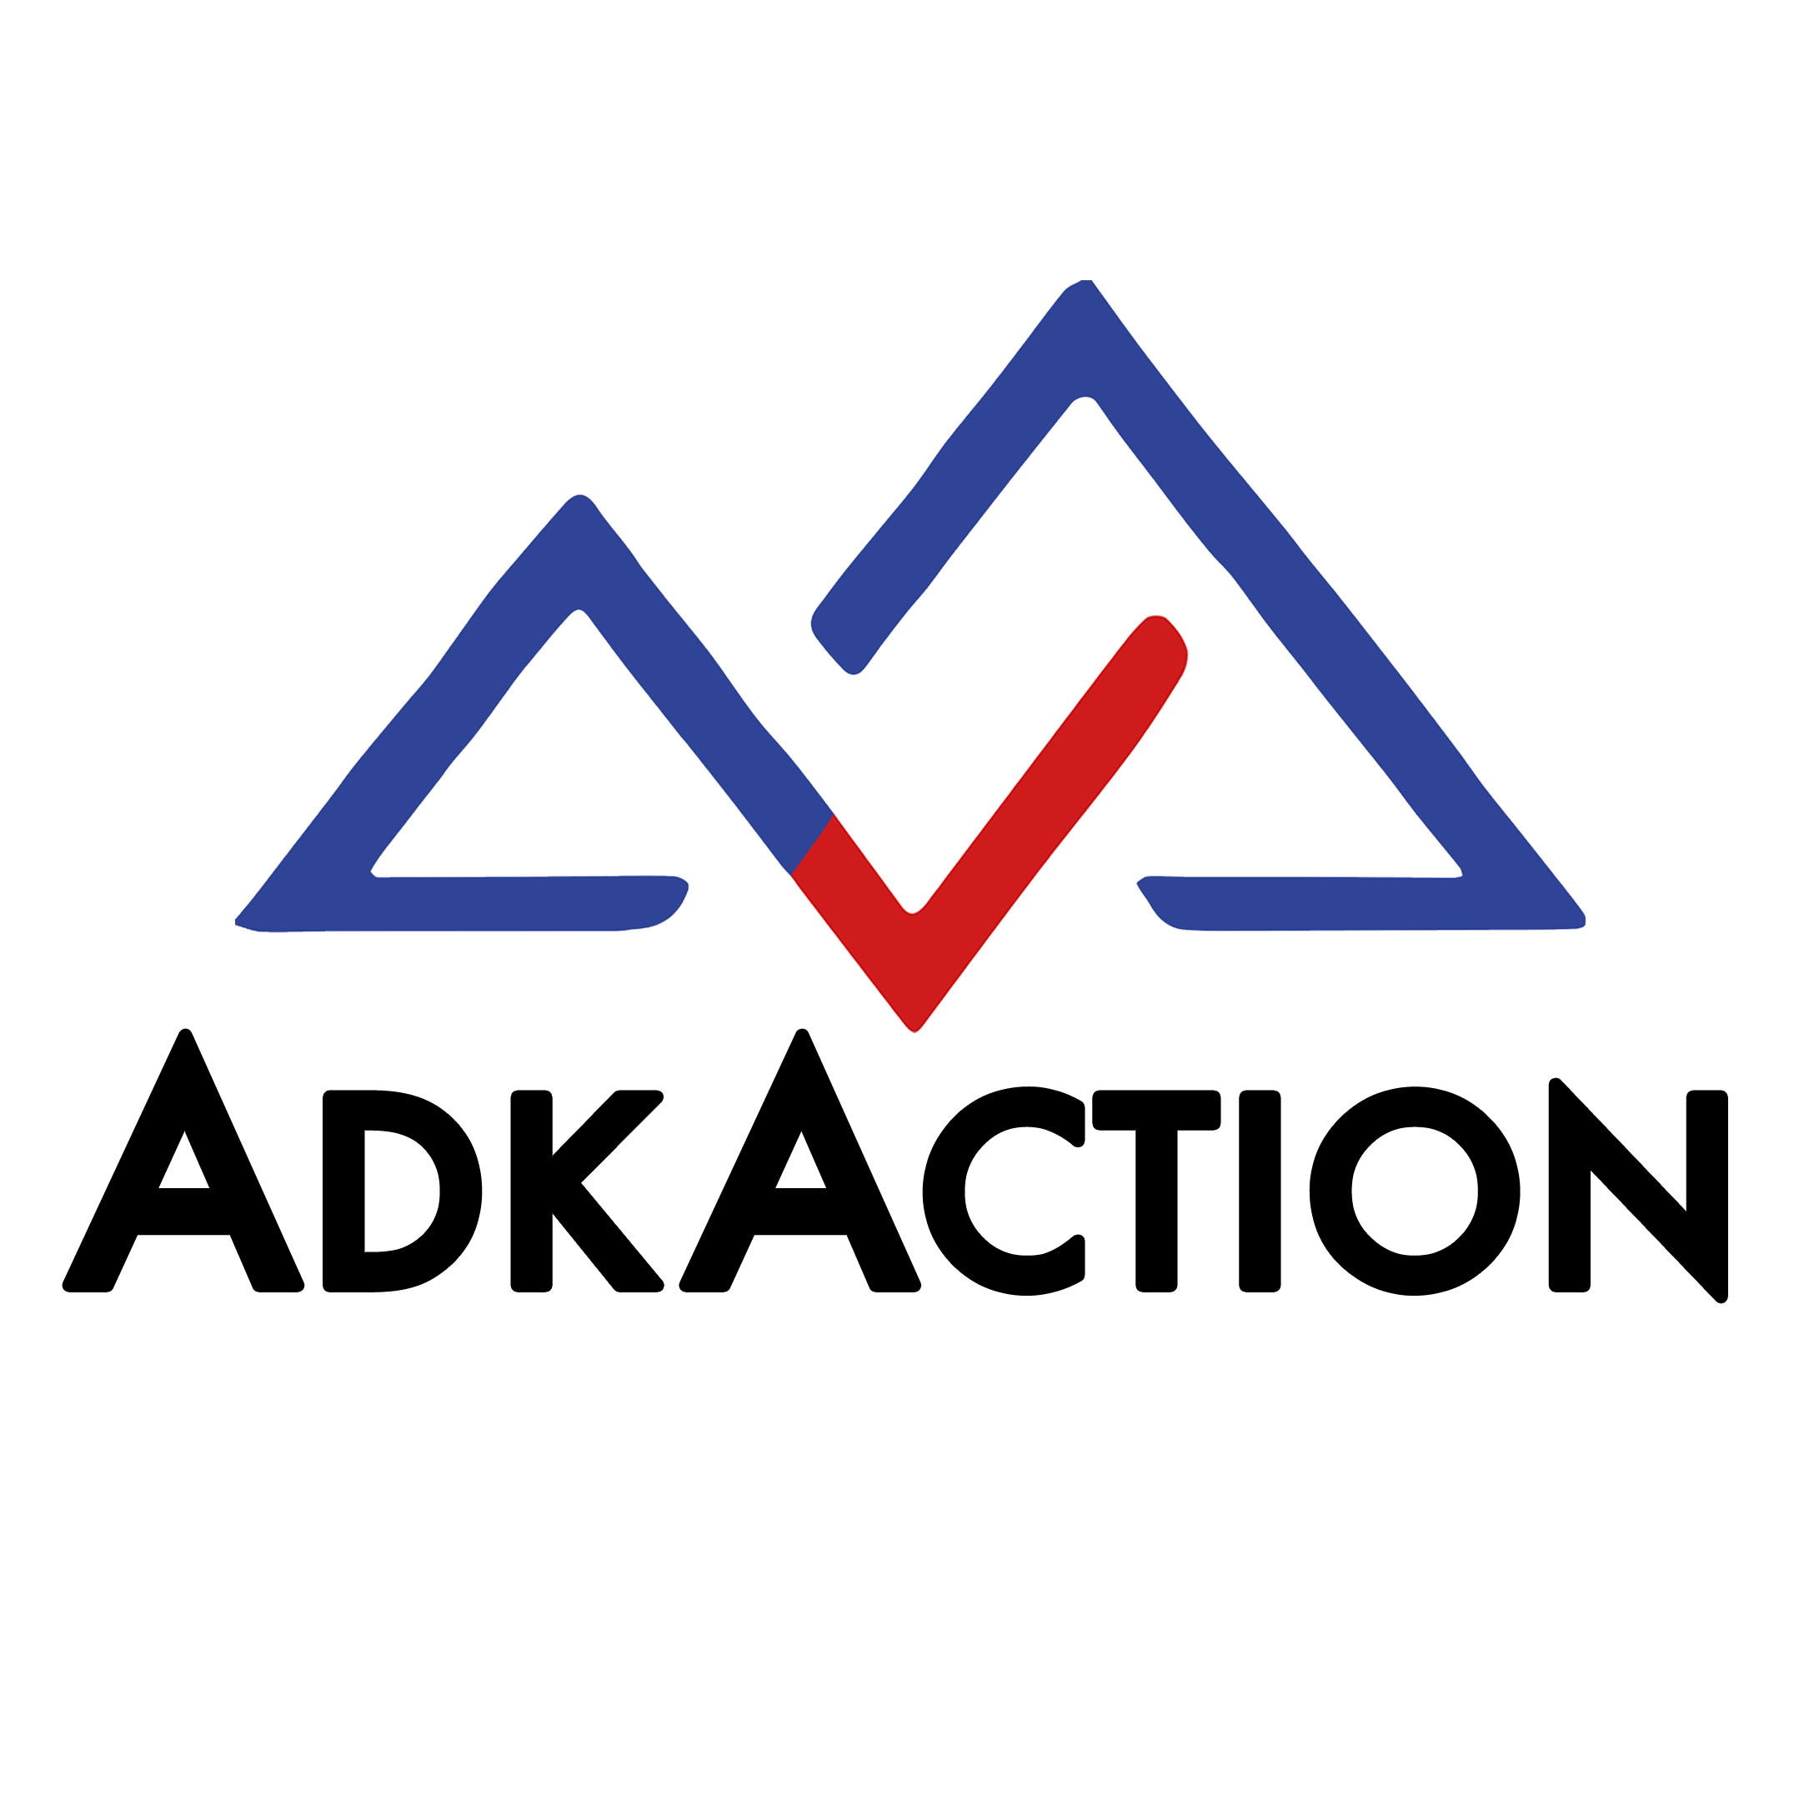
By:_____________________________________________________________ Date:_________________

Part of AdkAction’s Adirondack Road Salt Working Group, an effort to reduce road salt
in the Adirondack Park.
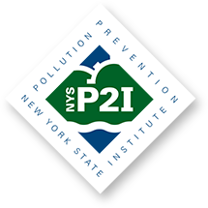
* Funding provided by the Environmental Protection Fund as administered by the New York State Department of Environmental Conservation. Any opinions, findings, and/or interpretations of data contained herein are the responsibility of the author(s) and do not necessarily represent the opinions, interpretations or policy of Rochester Institute of Technology and its NYS Pollution Prevention Institute or the State.

